TITLE

Author*, Author *, Author ** y Author ***
*UniversityA; **UniversityB; ***UniversityC

Number of words (<1900):
Abstract
Not exceed the 200 words. The abstract should be structured according to the following sections: Background, Method, Results and Conclusions.
Keywords: between three and five words separated by commas.

Abstract
Not exceed the 200 words. The abstract should be structured according to the following sections: Background, Method, Results and Conclusions.
Keywords: between three and five words separated by commas.

Level 1
(Introduction, Method, Results, Discussion/Conclusions and References)
The format of the heading of Level 1 is in bold font, centered and in lower case letters. Headings of Level 1 are usually: Introduction, Method, Results and Discussion/Conclusions.
The manuscripts must be written in Times New Roman, with 12-point font size, 1.5 points of line spacing. No spaces must be between the different paragraphs; in order to differentiate them, they must be indented 1 cm. Margins of 3 cm must be left in every page.
Notes, in case they are indispensable to be included, must be at the bottom of the page to which each note belongs to, and numbered consecutively, and, in any case they are used to include references.

Level 2 (Materials, Participants, Design, Procedure)
The format of the heading of Level 2 is left-hand margined, bold, in lowe case letters and without tabulation. Headings of Level 2 are usually: Materials, Participants, Design, Procedure, and so on.
Tables and figures, with their corresponding headings and captions, must be included in the manuscript placed next to their corresponding text. The table heading must be placed above the table body. For example:

Table 1
Medias de porcentaje de aciertos en graduados y licenciados en la prueba objetiva, tanto en su totalidad como en función del área de conocimiento, diferencia de medias.
 |  | 4º grado |  |  | 5º licenciatura
Área de conocimiento |  | Mª | DT |  | Mª | DT |  | t | p
Área 1 |  | 29.92 | 16.47 |  | 28.39 | 15.72 |  | 1.19 | .232
Área 2 |  | 36.97 | 15.23 |  | 35.59 | 15.69 |  | 1.13 | .257
Área 3 |  | 28.23 | 20.78 |  | 22.29 | 17.63 |  | 3.86 | .000
Área 4 |  | 62.18 | 19.82 |  | 62.41 | 18.82 |  | -0.15 | .876
Área 5 |  | 38.06 | 21.66 |  | 35.59 | 20.38 |  | 1.47 | .140
Área 6 |  | 44.84 | 15.79 |  | 50.97 | 20.73 |  | -4.27 | .000
Área 7 |  | 40.03 | 10.68 |  | 39.67 | 10.36 |  | 0.425 | .671
ªMedia del porcentaje de aciertos.

The heading of figures and graphics must be placed below them:

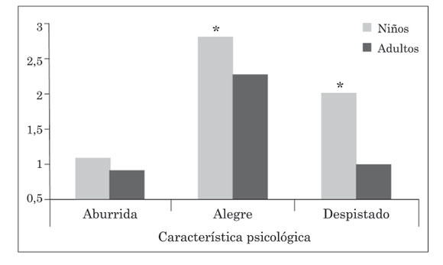
Figure 1. Puntuación media en característica psicológica, según edad. * p < 0,001.

References
All submitted manuscripts must follow the APA publication style (Publication Manual of the American Psychological Association, 5th or 6th edition). You can find some basic publication rules below:
In-text citations must include author(s) and year of publication (both in parentheses, separated by a comma). If the name of the author is part of the sentence, only the year of publication appears in parentheses. If the cited work has two authors, both authors are cited. If the work has more than two and less than six authors, all authors are cited the first time, appearing only the first author’s last name followed by “et al.” in subsequent citations. However, if there is another reference with same author(s) and same year of publication, the complete list of authors must be included. For works with more than six authors, write only the first author’s name followed by “et al.” Within parentheses, authors are listed by name, alphabetically. To cite works by the same author(s), with same year of publication, order them by using letters (a, b, c).
Bibliographical references will be listed alphabetically, according to the
following rules:

a) Books: Author (last name, comma, initials, dot; In case of many authors, separate their names by using “&”); Year of publication (in parentheses), dot; Full title (italics), dot.; city: publishing company.
Example: Rodríguez, S., Valle, A., Cabanach, R., & Núñez, J. C. (2010). Motivar enseñando: La integración de estrategias motivadoras en el curriculum escolar. Madrid: CCS.

b) Book chapter: Author(s); Year of publication; Full title, and (introduced by “In”) editor(s)/director(s) –name initials and last name- followed by (Ed.) and pages; city and publishing company.
Example: Cerezo, F. (2007). Violencia y victimización entre escolares. El bullying. In J. Méndez, J.P. Espada y Orgilés, M. (Eds.), Intervención psicológica y educativa con niños y adolescentes. Estudio de casos (pp. 171-187). Madrid. Pirámide Psicología.

c) Journal: Author(s); Year of publication; Full title; Name of the journal in italics; vol. in italics; number in italics; initial page number-final page number.
Example: Rosário, P., Abílio, A., Paiva, M.O., Núñez , J.C., González-Pienda, J.A. & Valle, A. (2012). Autoeficacia y utilidad percibida como condiciones necesarias para un aprendizaje académico autorregulado. Anales de Psicología, 28, 37-44.

d) Electronic documents: Author(s); Year of publication, dot; full title of the document, dot; retrieval date, comma; electronic source.
When the original version of the cited manuscript is not in English, the original
title must be cited, and, between brackets, its translation in English.

